Lab 8
Task 1:
CREATE VIEW flight_departures AS
SELECT
f.flight_id,
al.airline_name,
dep_air.airport_name AS from_airport,
arr_air.airport_name AS to_airport,
f.sch_departure_time AS departure,
f.departing_gate AS gate
FROM flights f
INNER JOIN airline al ON f.airline_id = al.airline_id
INNER JOIN airport dep_air ON f.departing_airport_id = dep_air.airport_id
INNER JOIN airport arr_air ON f.arriving_airport_id = arr_air.airport_id
WHERE DATE(f.sch_departure_time) = CURRENT_DATE
ORDER BY f.sch_departure_time;
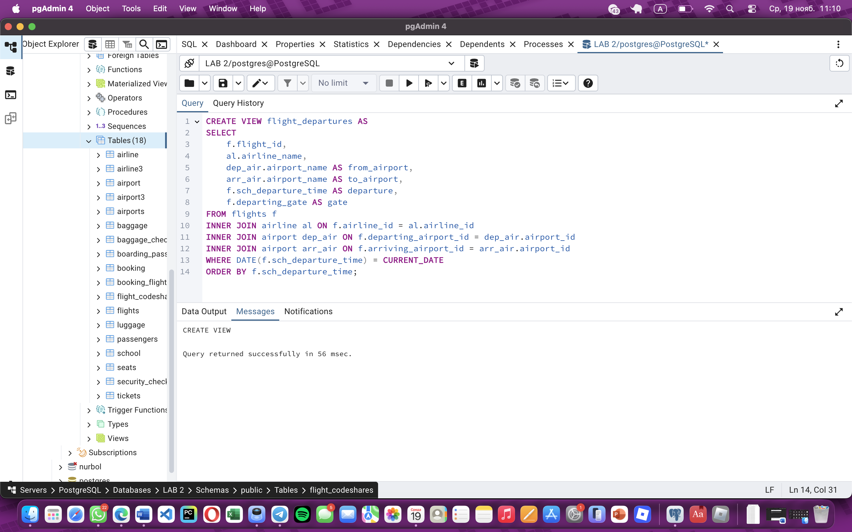
Task 2:
CREATE VIEW next_week_departure_bookings AS
SELECT
b.booking_id,
b.passenger_id,
b.booking_platform,
b.status AS booking_status,
(b.ticket_price - b.ticket_discount) AS final_price,

f.flight_id,
al.airline_name,
dep_air.airport_name AS from_airport,
arr_air.airport_name AS to_airport,
f.sch_departure_time AS departure,
f.departing_gate AS gate

FROM booking b
INNER JOIN flights f ON b.flight_id = f.flight_id
INNER JOIN airline al ON f.airline_id = al.airline_id
INNER JOIN airport dep_air ON f.departing_airport_id = dep_air.airport_id
INNER JOIN airport arr_air ON f.arriving_airport_id = arr_air.airport_id
WHERE f.sch_departure_time BETWEEN CURRENT_DATE AND CURRENT_DATE + INTERVAL '7 days'
ORDER BY f.sch_departure_time;
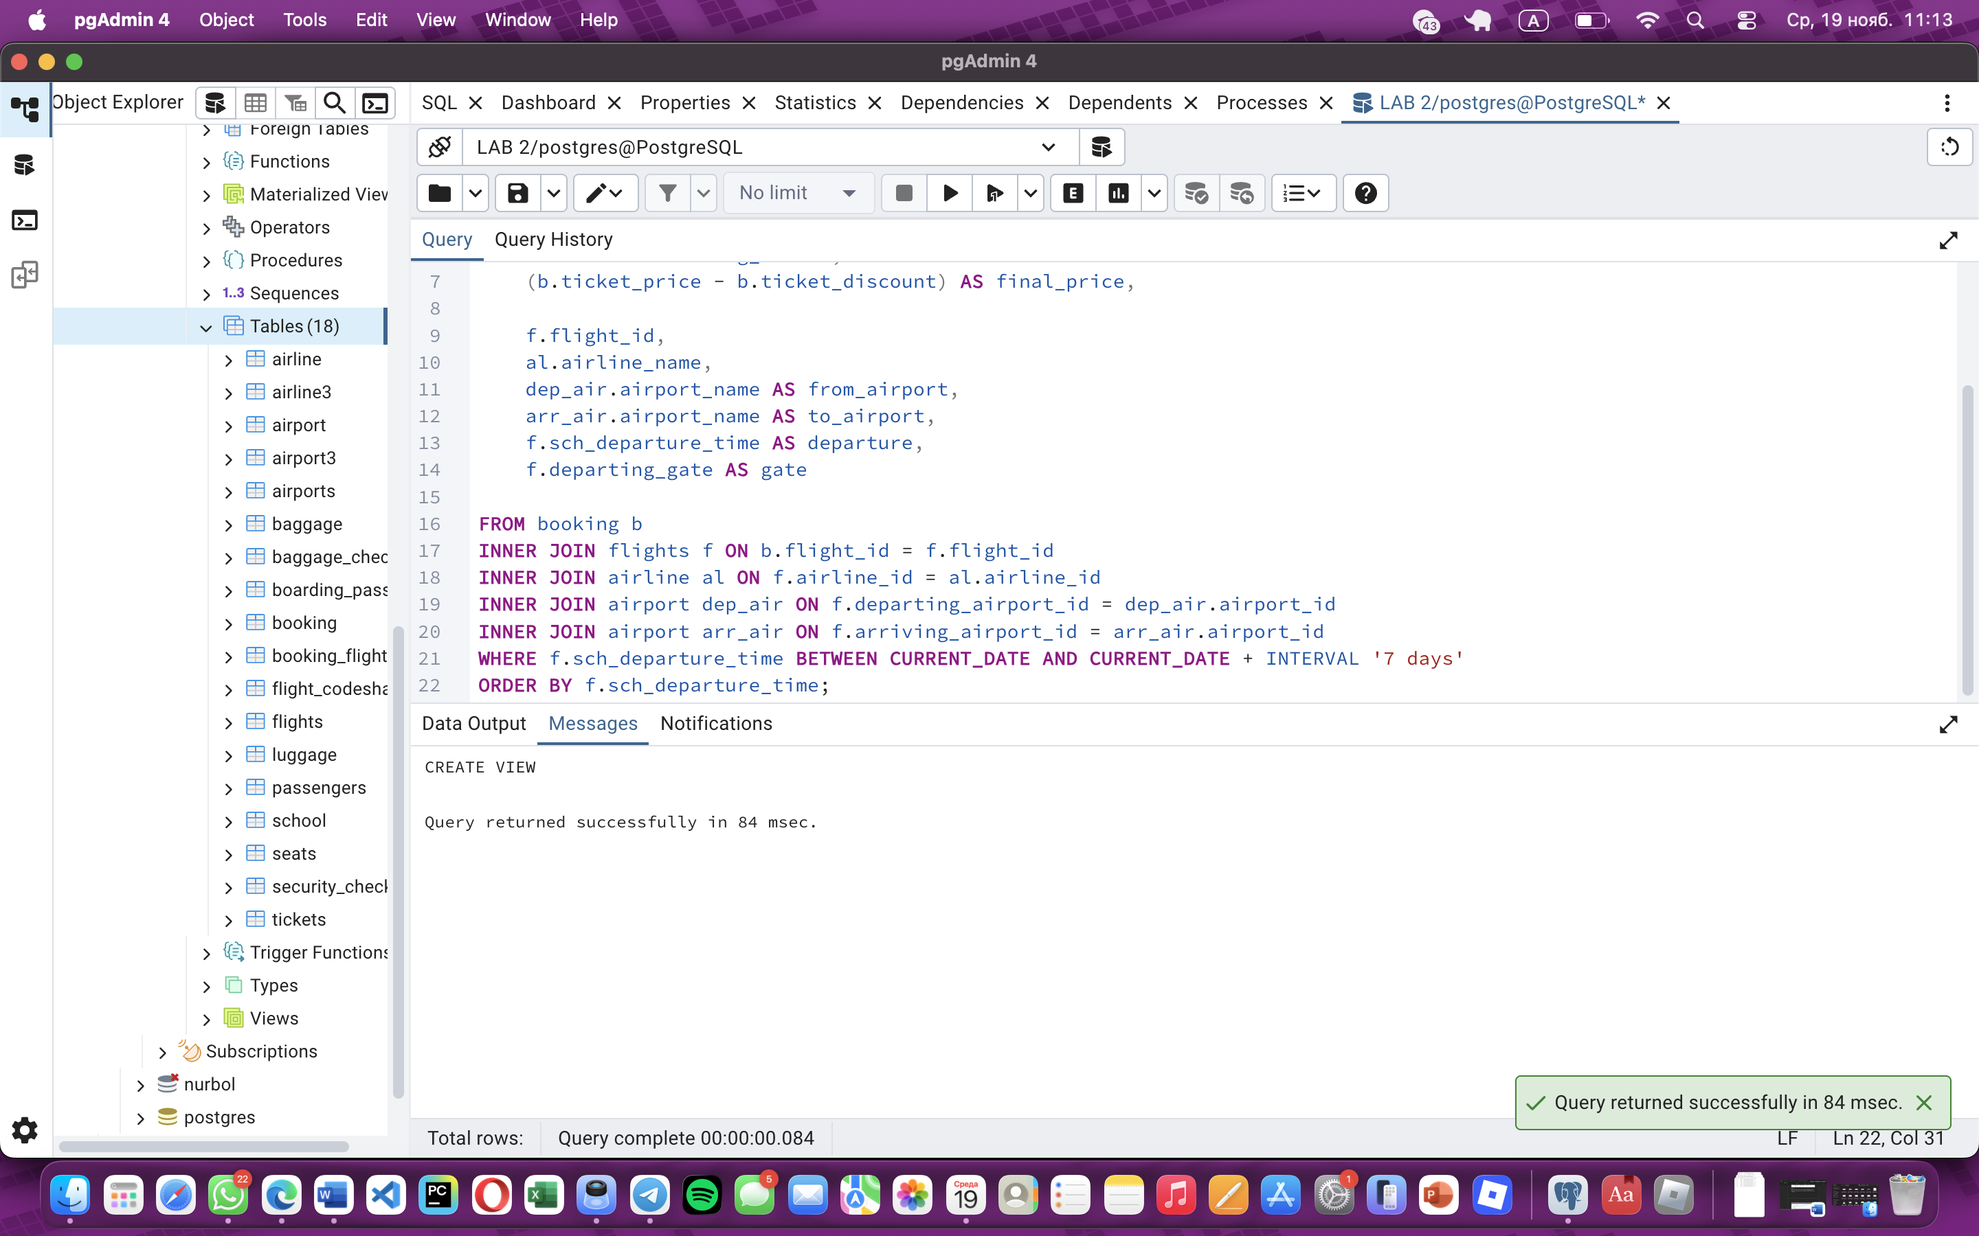
Task 3:
CREATE VIEW top_5_popular_routes AS
SELECT
CONCAT(dep_air.city, ' → ', arr_air.city) AS route,
COUNT(b.booking_id) AS total_bookings,
ROUND(AVG(b.ticket_price - b.ticket_discount), 2) AS avg_ticket_price
FROM booking b
INNER JOIN flights f ON b.flight_id = f.flight_id
INNER JOIN airport dep_air ON f.departing_airport_id = dep_air.airport_id
INNER JOIN airport arr_air ON f.arriving_airport_id = arr_air.airport_id
GROUP BY dep_air.city, arr_air.city
ORDER BY total_bookings DESC
LIMIT 5;
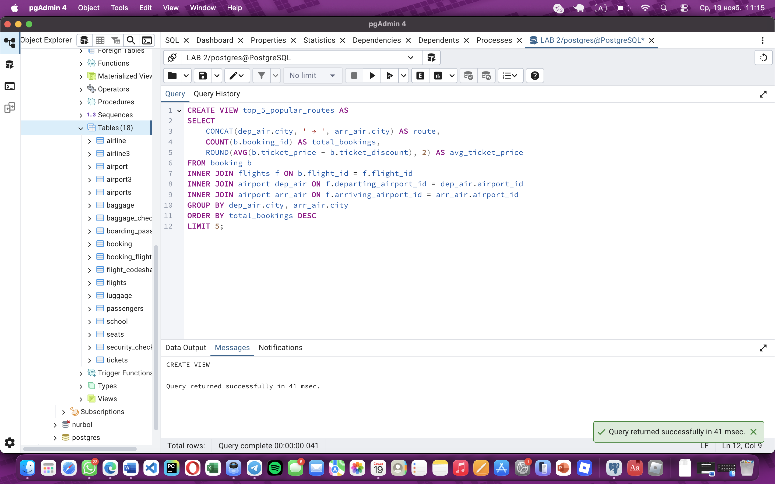
Task 4:
CREATE VIEW airline_flights_simple AS
SELECT
f.flight_id,
al.airline_name,
al.airline_code,
dep_air.airport_name AS from_airport,
dep_air.city AS from_city,
arr_air.airport_name AS to_airport,
arr_air.city AS to_city,
f.sch_departure_time AS departure,
f.sch_arrival_time AS arrival,
f.departing_gate AS gate
FROM flights f
INNER JOIN airline al ON f.airline_id = al.airline_id
INNER JOIN airport dep_air ON f.departing_airport_id = dep_air.airport_id
INNER JOIN airport arr_air ON f.arriving_airport_id = arr_air.airport_id
ORDER BY al.airline_name, f.sch_departure_time;
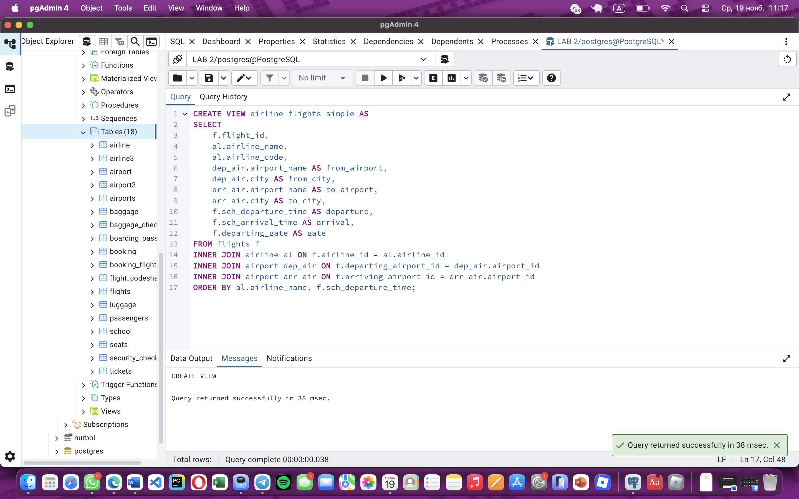
Task 5:
CREATE OR REPLACE VIEW airline_flights_simple AS
SELECT
f.flight_id,
al.airline_name,
al.airline_code,
dep_air.airport_name AS from_airport,
dep_air.city AS from_city,
arr_air.airport_name AS to_airport,
arr_air.city AS to_city,
f.sch_departure_time AS departure,
f.sch_arrival_time AS arrival,
f.departing_gate AS gate,
EXTRACT(DAYS FROM (f.sch_departure_time - CURRENT_TIMESTAMP))::INT AS days_until_departure
FROM flights f
INNER JOIN airline al ON f.airline_id = al.airline_id
INNER JOIN airport dep_air ON f.departing_airport_id = dep_air.airport_id
INNER JOIN airport arr_air ON f.arriving_airport_id = arr_air.airport_id
WHERE f.sch_departure_time BETWEEN CURRENT_DATE AND CURRENT_DATE + INTERVAL '7 days'
ORDER BY al.airline_name, f.sch_departure_time;
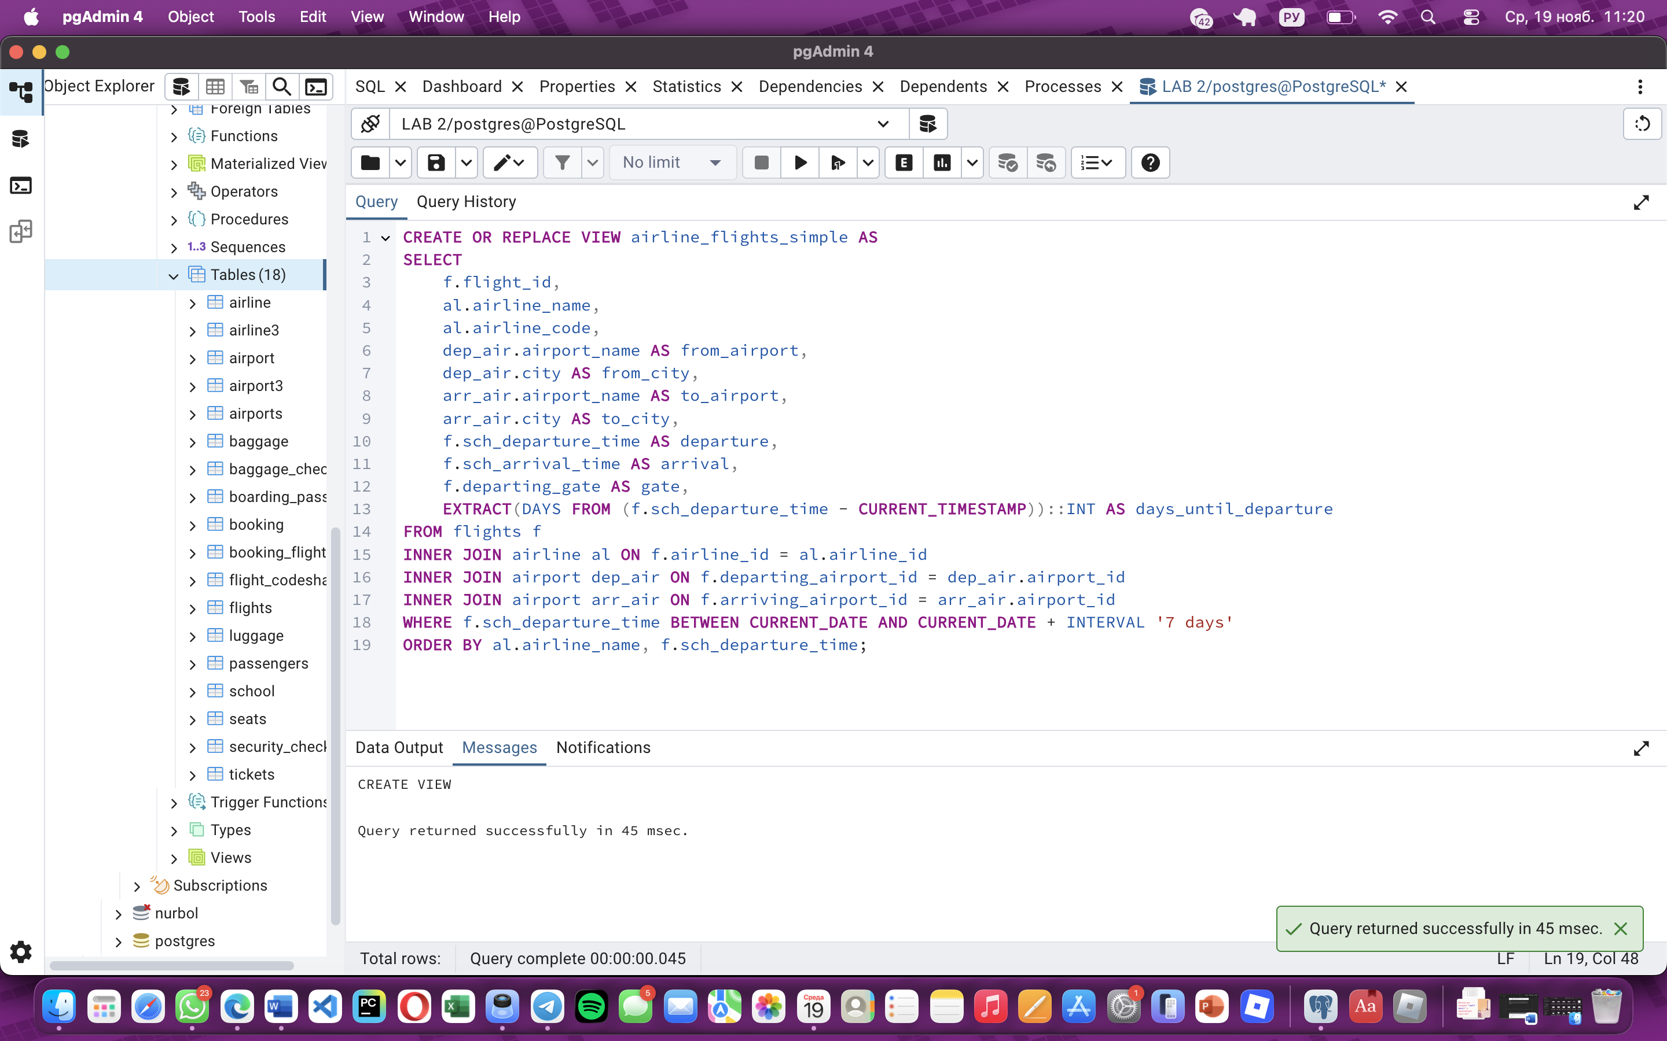
Task 6:
CREATE VIEW flights_delayed_over_24_hours AS
SELECT
f.flight_id,
al.airline_name,
CONCAT(dep_air.city, ' → ', arr_air.city) AS route,
f.sch_departure_time AS scheduled,
f.act_departure_time AS actual,
ROUND(EXTRACT(EPOCH FROM (f.act_departure_time - f.sch_departure_time))/3600, 1) AS delay_hours,
f.departing_gate AS gate
FROM flights f
INNER JOIN airline al ON f.airline_id = al.airline_id
INNER JOIN airport dep_air ON f.departing_airport_id = dep_air.airport_id
INNER JOIN airport arr_air ON f.arriving_airport_id = arr_air.airport_id
WHERE (f.act_departure_time - f.sch_departure_time) > INTERVAL '24 hours'
ORDER BY delay_hours DESC;
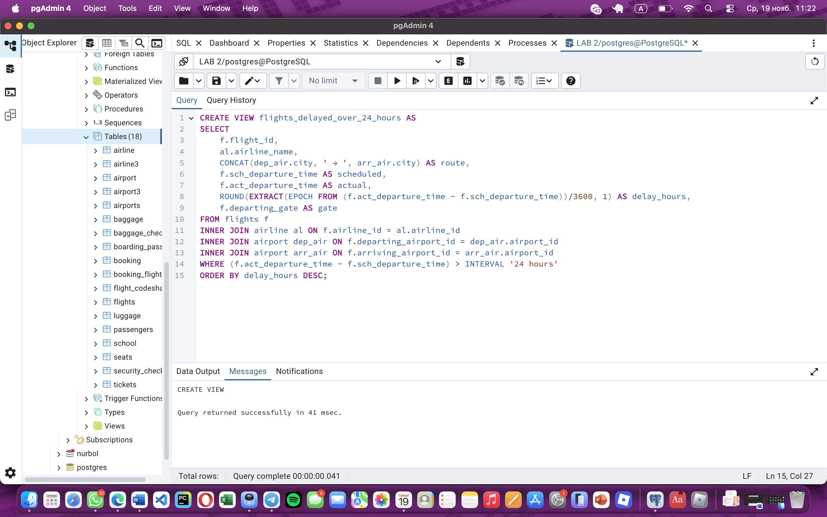
Task 7:
CREATE VIEW leffler_thompson_passengers AS
SELECT
b.booking_id,

-- Passenger details
p.passenger_id,
CONCAT(p.first_name, ' ', p.last_name) AS full_name,
p.country_of_citizenship AS country_of_origin,
p.country_of_residence,
p.date_of_birth,
p.gender,

-- Booking details
b.booking_platform,
b.status AS booking_status,
b.ticket_price,
b.ticket_discount,
(b.ticket_price - b.ticket_discount) AS final_price,
b.created_at AS booking_date,

-- Flight details
f.flight_id,
f.sch_departure_time AS departure_time,
f.sch_arrival_time AS arrival_time,

-- Airline details
al.airline_name,

-- Airport details
dep_air.airport_name AS departure_airport,
dep_air.city AS departure_city,
dep_air.country AS departure_country,
arr_air.airport_name AS arrival_airport,
arr_air.city AS arrival_city,
arr_air.country AS arrival_country

FROM booking b
INNER JOIN passengers p ON b.passenger_id = p.passenger_id
INNER JOIN flights f ON b.flight_id = f.flight_id
INNER JOIN airline al ON f.airline_id = al.airline_id
INNER JOIN airport dep_air ON f.departing_airport_id = dep_air.airport_id
INNER JOIN airport arr_air ON f.arriving_airport_id = arr_air.airport_id
WHERE b.booking_platform = 'Leffler-Thompson'
ORDER BY p.last_name, p.first_name;
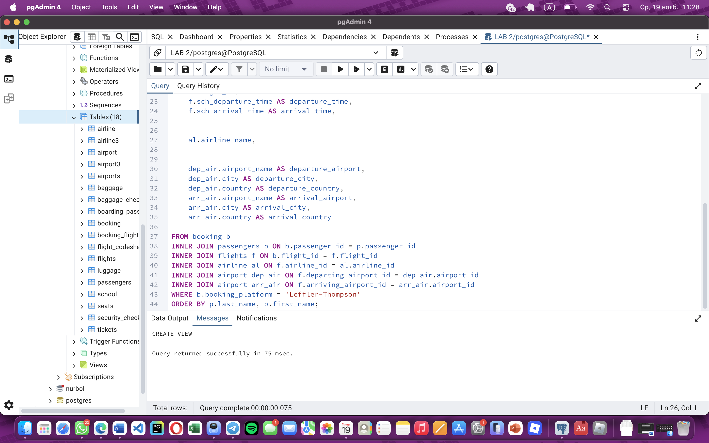
Task 8:
CREATE VIEW top_10_visited_countries AS
SELECT
arr_air.country AS country,
COUNT(b.booking_id) AS visitor_count,
RANK() OVER (ORDER BY COUNT(b.booking_id) DESC) AS ranking
FROM booking b
INNER JOIN flights f ON b.flight_id = f.flight_id
INNER JOIN airport arr_air ON f.arriving_airport_id = arr_air.airport_id
WHERE b.status IN ('Confirmed', 'Checked')
GROUP BY arr_air.country
ORDER BY visitor_count DESC
LIMIT 10;
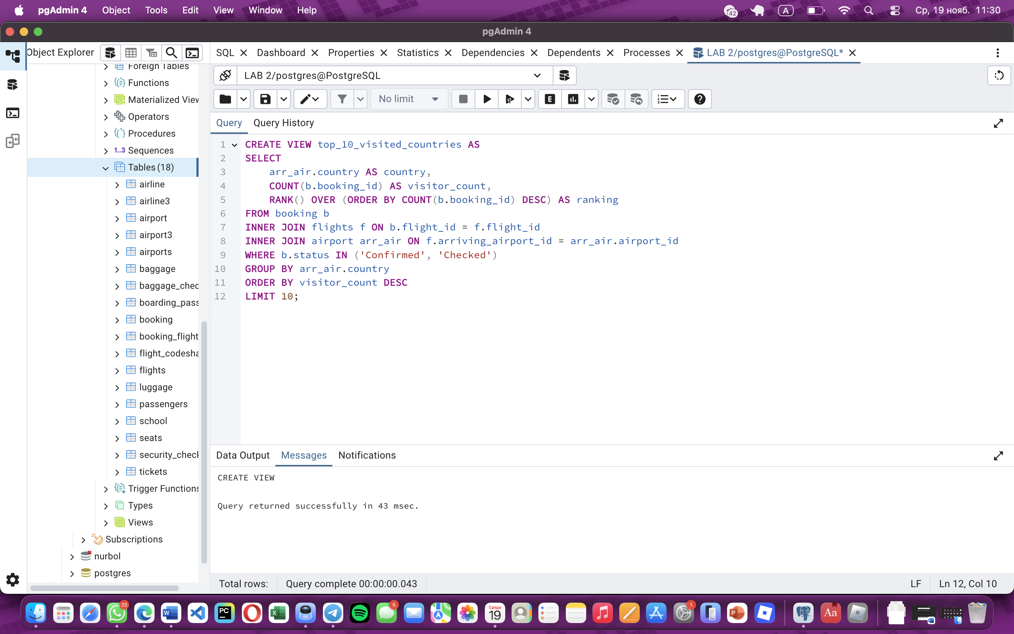
Task 9:

DROP VIEW IF EXISTS top_10_visited_countries;

CREATE VIEW top_10_visited_countries AS
SELECT
arr_air.country AS destination_country,
COUNT(b.booking_id) AS total_visits,
COUNT(DISTINCT b.passenger_id) AS unique_visitors,
COUNT(DISTINCT f.flight_id) AS total_arriving_flights,
COUNT(DISTINCT al.airline_id) AS airlines_serving,
ROUND(AVG(b.ticket_price - b.ticket_discount), 2) AS avg_ticket_price,
SUM(b.ticket_price - b.ticket_discount) AS total_revenue,

COUNT(DISTINCT CASE WHEN p.gender = 'M' THEN p.passenger_id END) AS male_visitors,
COUNT(DISTINCT CASE WHEN p.gender = 'F' THEN p.passenger_id END) AS female_visitors,
ROUND(AVG(EXTRACT(YEAR FROM AGE(CURRENT_DATE, p.date_of_birth))), 1) AS avg_visitor_age,

COUNT(DISTINCT CASE WHEN b.booking_platform = 'Website' THEN b.booking_id END) AS website_bookings,
COUNT(DISTINCT CASE WHEN b.booking_platform = 'Mobile App' THEN b.booking_id END) AS mobile_app_bookings,
COUNT(DISTINCT CASE WHEN b.booking_platform = 'Travel Agency' THEN b.booking_id END) AS travel_agency_bookings,

ROUND(COUNT(b.booking_id)::DECIMAL / NULLIF(COUNT(DISTINCT b.passenger_id), 0), 2) AS avg_visits_per_visitor,
ROUND(SUM(b.ticket_price - b.ticket_discount) / NULLIF(COUNT(b.booking_id), 0), 2) AS revenue_per_visit

FROM booking b
INNER JOIN passengers p ON b.passenger_id = p.passenger_id
INNER JOIN flights f ON b.flight_id = f.flight_id
INNER JOIN airline al ON f.airline_id = al.airline_id
INNER JOIN airport arr_air ON f.arriving_airport_id = arr_air.airport_id
WHERE b.status IN ('Confirmed', 'Checked', 'Pending')
GROUP BY arr_air.country
ORDER BY total_visits DESC
LIMIT 10;
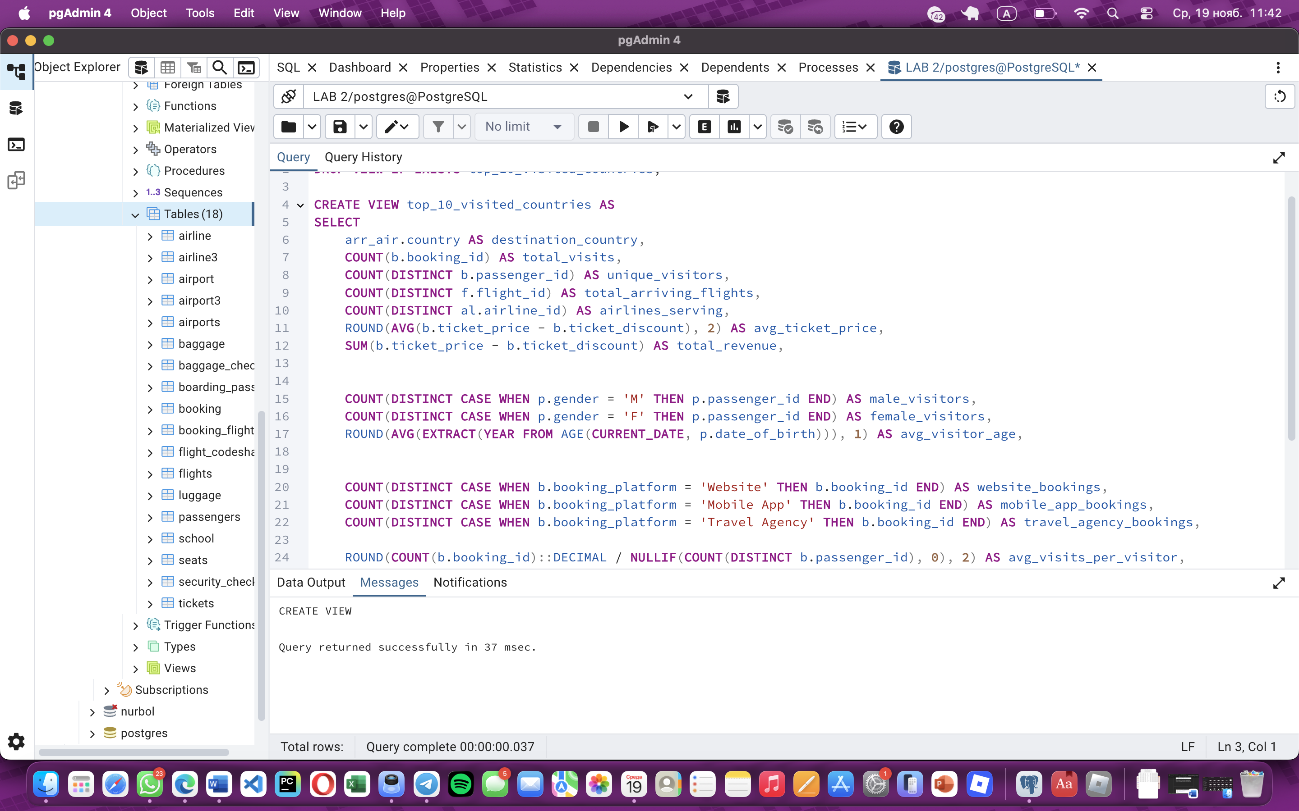
Task 10:

